rush of service

Game Design Document – Initial Draft

COurtney adams

Academy of Interactive Entertainment

Contents

CORE CONCEPT 2

GENRE 2

PLATFORM 2

GAMEPLAY LOOP 3

TARGET AUDIENCE ANALYSIS 4

COMPETITOR ANALYSIS 5

ART OVERVIEW 7

ECONOMY SYSTEM OVERVIEW 9

REWARD LOOP OVERVIEW 11

FEEDBACK LOOP 12

NARRATIVE OVERVIEW 13

# CORE CONCEPT

The player oversees running a small café, managing the menu and their ingredients. Players will discover new recipes as the game progresses, adding a more challenging experience as the player must manage more efficiently to maintain a high rating for their café.

Players will experience the ‘Rush of Service’, preparing, making and serving food in the busy hours, and then managing their ingredients and changes to their menu at days end. Changes to the menu will impact customer satisfaction, which therefore impacts café rating, potentially resulting in a loss or gain of customers.

This game offers a quick yet rewarding experience with plenty of options for players to control, including; customization of their own café, their own menus and ingredients and seeing how they apply to the success of their café.

The choice of platform is geared towards “on-the-go” play, allowing it to be accessible to a large range of consumers who wish to experience quick and rewarding gameplay. In game days will be short, resulting in numerous loops of rewards and satisfying management mechanics to almost constantly be experienced by the player.

# GENRE

Management, simulator, casual, strategy.

# PLATFORM

iOS devices (iPhone, iPod, iPad etc.)

Android devices

Nintendo Switch

# GAMEPLAY LOOP

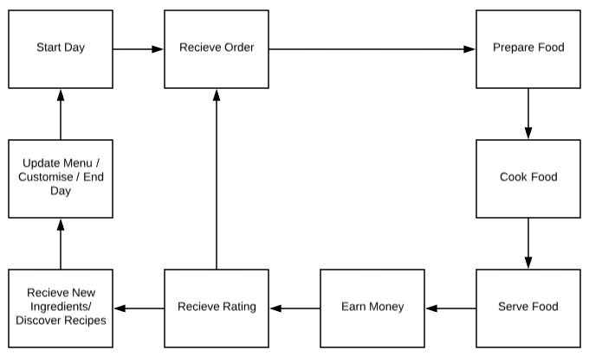

Players will always start and end their days on the same menu. Players will immediately begin their day, receiving, preparing, cooking and serving orders to hungry customers. Based on their speed, the player will receive a rating. As the in-game time ticks by, with various levels of difficulty presenting itself, the player will reach the end of the day.

During the ‘end of day’ phase, players will be shown their rating, the customers served and their individual rating and the new ingredients they have collected. The player will then be shown new recipes they have discovered, which can later be applied to their menu, before starting the next day.

# TARGET AUDIENCE ANALYSIS

Rush of Service aims to give a fast-paced, rewarding and simple management game where players can easily access while on the go, hence it’s focus on platforms that offer touch screen capability.

Players will be able to pause their game at any time yet will only be able to save at the end of their days. Days will progress quickly and offer spikes in difficultly to add more interest and determination to the player, as the better they perform, the better rewards they receive.

Players also have full control over their menu, as well as customizable options for their café, which can be purchased with in-game currency, earned by serving customers. This allows the player to manage currency, ingredients and their menu, all whilst maintaining a rating applied to their café.

This meets the target audience’s needs because it fulfills the fun, tense gaming feel of a management game, which can be played on the go. It caters to a casual market, that want a short, yet satisfying and rewarding experience for their efforts. With inclusion of touch screen devices, extending its market to the Nintendo Switch means that players can now experience ‘Rush of Service’ in their homes on their personal televisions and monitors, creating a more permanent set up if it is so desired by the consumer.

# COMPETITOR ANALYSIS

Numerous games of this description do already exist on the market, some very similar that do not revolve around the management of a café. Numerous titles include;

* Little Dragons Café
  + Little Dragons Café was a game released purely on the Nintendo Switch console, it received praise for its art style, narrative and interesting twist on owning a pet dragon. However, it was criticized for its lack of management, activities and repetitive gameplay that offered unsatisfactory rewards.
* My Café: Recipes and Stories
  + This game was released on both iOS and Android software, quickly becoming one of the highest grossing and most popular café management simulator games on the market. It was praised for its amounts of investment within the game, giving the player control over prices of items and having them remember and prepare recipes themselves which kept a constant form of gameplay. It was criticized for the numerous amounts of relevant currencies and the prices of microtransactions tied to them.
* My Café Story
  + My Café Story was released on both iOS and Android systems. It was praised for its art style and the ability to create your own recipes. It was also praised for its continuation in the series, having been three different iterations of the game. It was criticized however, in the long grind to save money and the limited range of recipes that were recognized by the game.
* Coffee Café
  + Coffee Café was released on iOS and Android devices. This game focuses more on the rush of service and making customers happy than it does the management side of gameplay. It was praised for its spikes in difficulty and the quick, yet skilled responses required to successfully play the game. However, in the long term, people criticized it for eventual boring and repetitive gameplay that proved to no longer serve as a challenge.

Rush of Service will stand out from the market because of its culmination of multiple forms of seamless, satisfying and rewarding gameplay. Its focus for casual and management focused players who are wanting more challenge, management and satisfying experiences will embrace the needs and desires of said target market, all whilst keeping a sense of familiarity and customization of games of similar genres.

# ART OVERVIEW

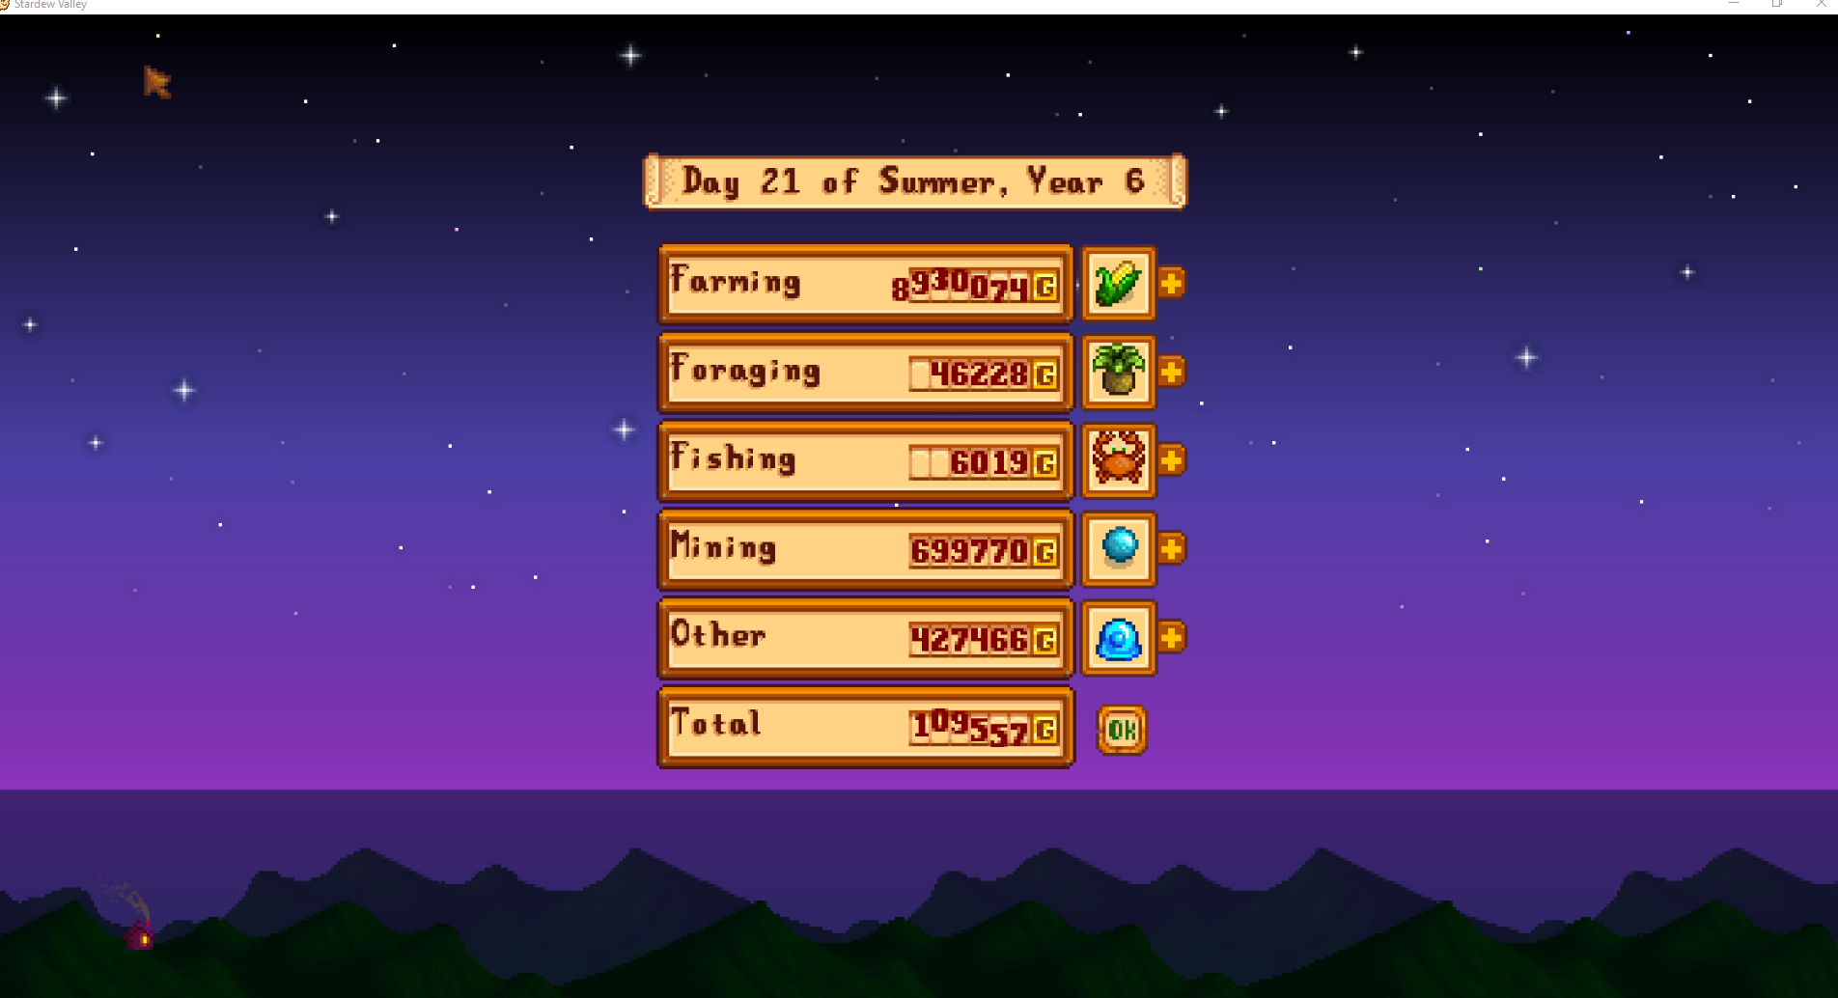

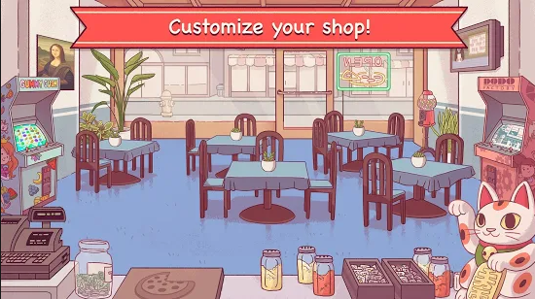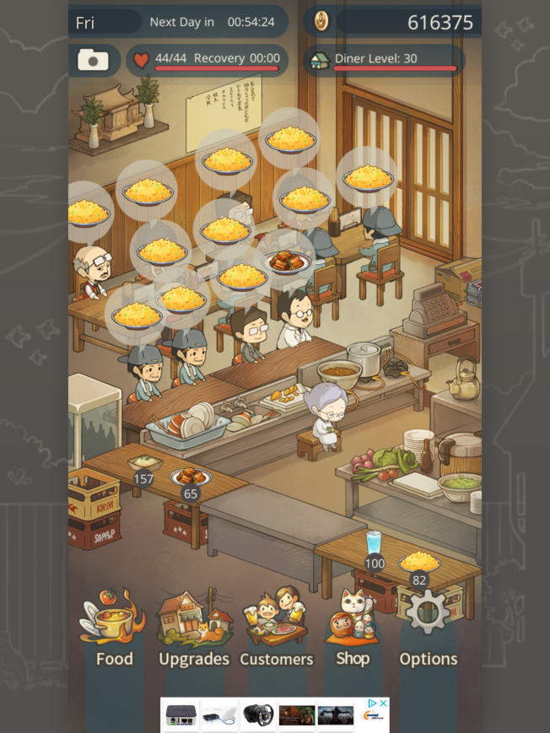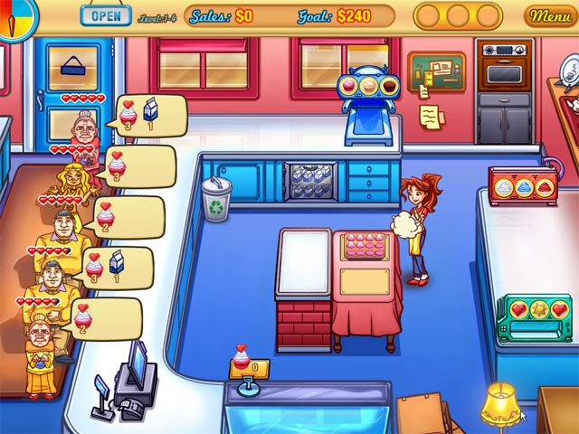

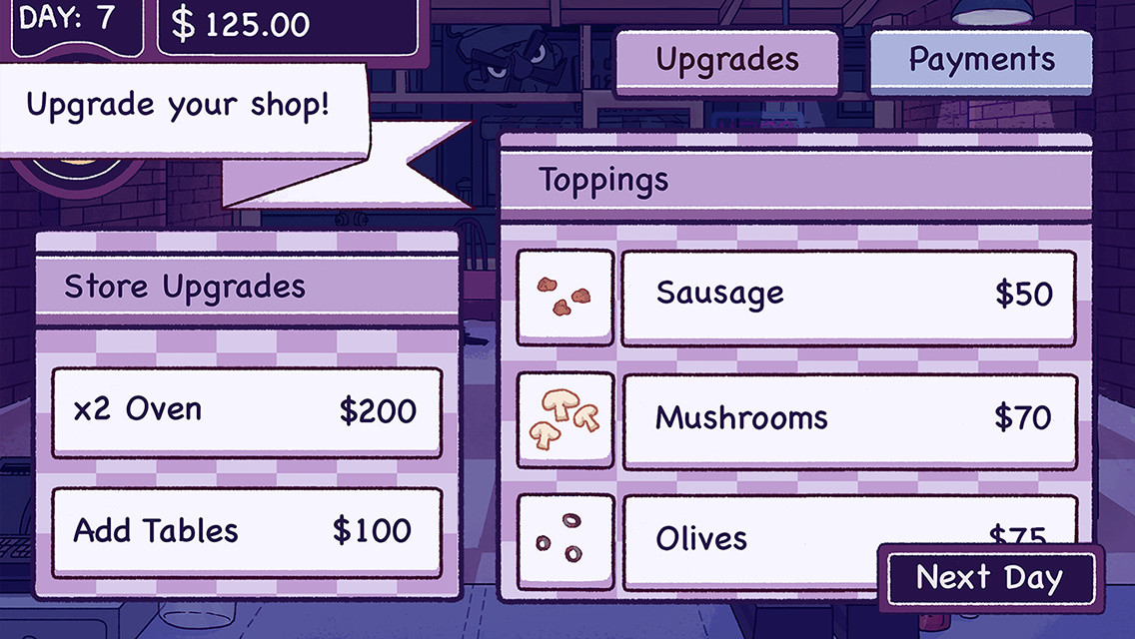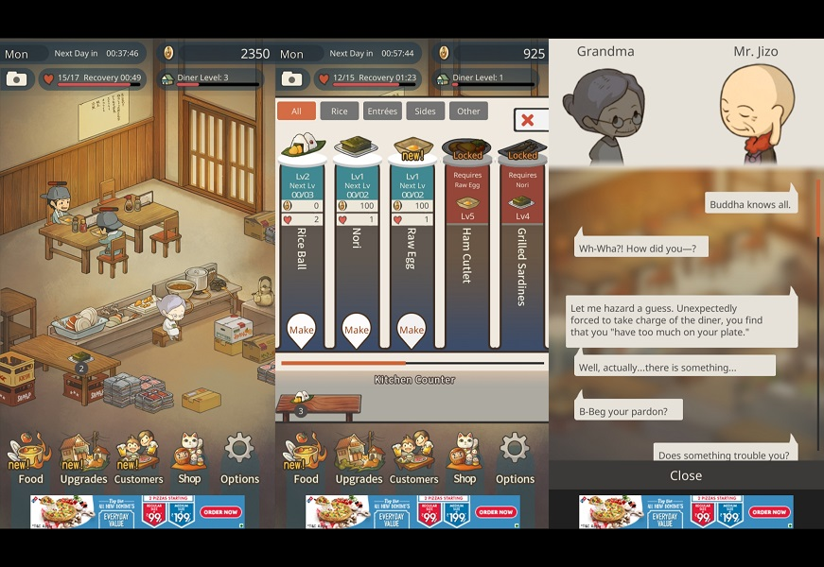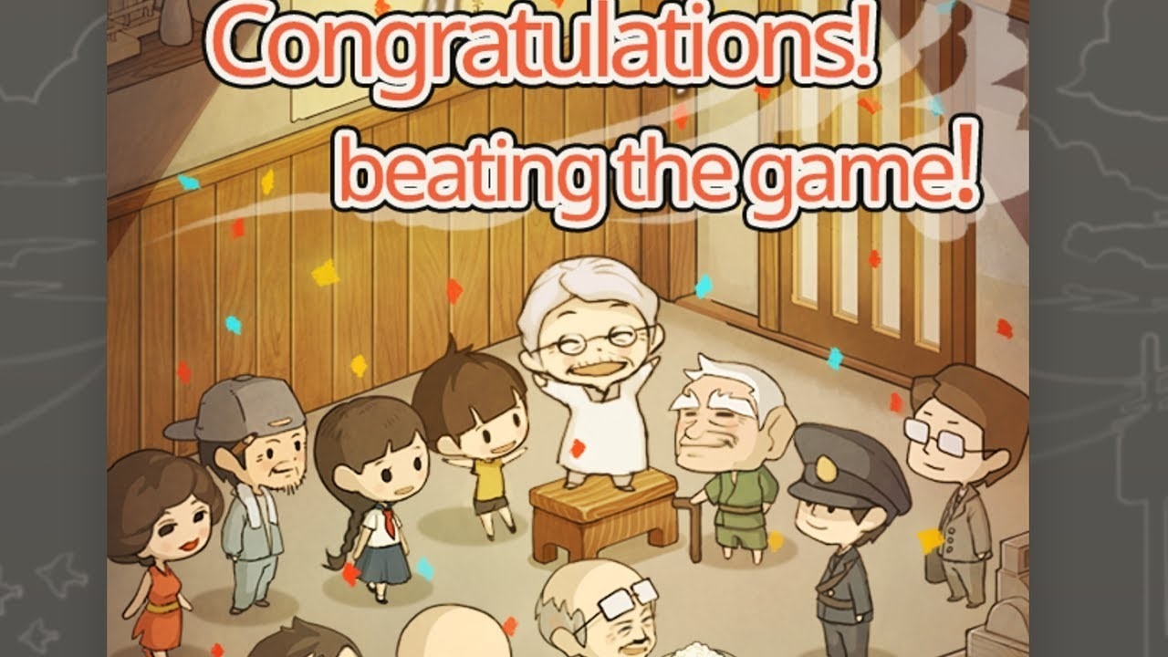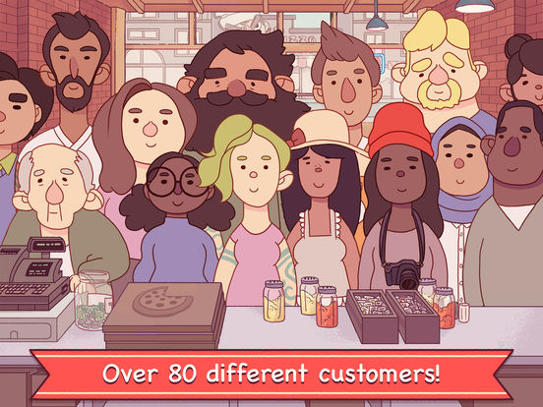

# ECONOMY SYSTEM OVERVIEW

* Money (buy ingredients and furniture)
* Ingredients
* Rating (café and customer)

‘Rush of Service will focus on four main economies within the game. These include;

* Money
* Ingredients
* Recipes
* Rating

Effectively, earning these “currencies” revolve around serving customers, the more effectively it is completed, the more the player earns. To break down further;

* Money will be earnt through serving each individual customer, consider this as a ‘tip’. The faster players can serve the customer, the higher the tip. Money can be spent on ingredients or different furniture and customization options within their café.
* Ingredients will be earnt at the end of each day, the quantity and variation of which will, again, rely on how effectively customers will be served.
* Recipes will also be earnt at the end of each day, the rarity and quantity of recipes earnt will rely on the customers satisfaction with the players performance
* Rating will be separated into two categories; customer and café.
  + Customer
    - When the player completes serving a customer, a simple emoticon with corresponding colors will be presented. There will be four different variations; green (happy), yellow (wanting improvement), red (unhappy) and black (walked out). The quantity of which the player receives throughout the day will be tallied to the café’s rating.
  + Café
    - If the player receives good feedback from their customers, it will positively impact their café’s rating. If the player receives poor feedback, if will negatively impact their customer’s rating. Therefore, the player should be aiming to satisfy every customer to receive the best rewards and improve their café as they continue to play.

# REWARD LOOP OVERVIEW

Players will gain their rewards throughout an in-game day; however, they cannot be applied until the end of day phase. Basic ‘rewards’ in the form of emoticons representing customers satisfaction will give the player an indication of how good their end of day results will be.

Players end of day results revolve around their café rating, new recipes and ingredients. The quality and quantity of these rewards depends on their customer service ratings that they receive during the day.

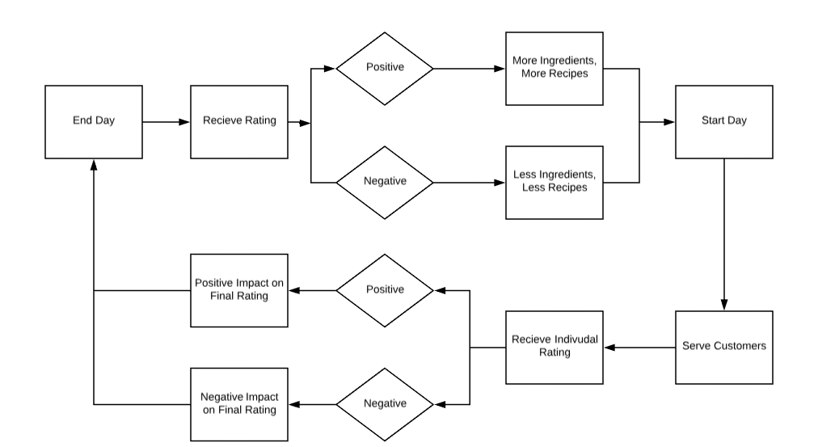

# FEEDBACK LOOP

Players will constantly be receiving feedback during their play time; the main form of feedback players will receive for their efforts is simple, yet colorful emoticons represented their customers happiness with their service.



Other forms of feedback will mostly be presented during the end of day phase, where players will overview a menu of their progress. This will include what they have gained, their rating and later their customization options for their café.





# NARRATIVE OVERVIEW

‘Rush of Service’ will not overly focus on a developed narrative story, instead, players will be able to create their own narrative through their customization choices within the game and the success they bring to their café.

The slight focus on narrative will provide the players with a character, of whom has just taken over his/her mother’s business. The player will be introduced to the rush of the café, and then begin to understand the management side of running a café. This loop will continue in quick play sessions and become more complicated yet therefore satisfying to the player.

The narrative will focus on the discovery of new recipes, which the player will see impact their café and it’s rating. It will also focus on the interior customization of their café, with more luxurious furniture items being available at higher currency prices, of which the player can not achieve without spending an enough in-game time playing.